We are so happy you are submitting a recipe. If you experience any difficulties while using the application or have questions, please email cookbook@stpeterchanel.org.

Disclaimer: The Core Committee will have the final choice of which recipes will be included. This decision will be based on the number of recipes an individual submits, duplicate recipes, and recipe quantities in a particular section. We are limited to 295 recipes and trying to include as many parishioner’s recipes as possible in this keepsake 25th Anniversary Celebration

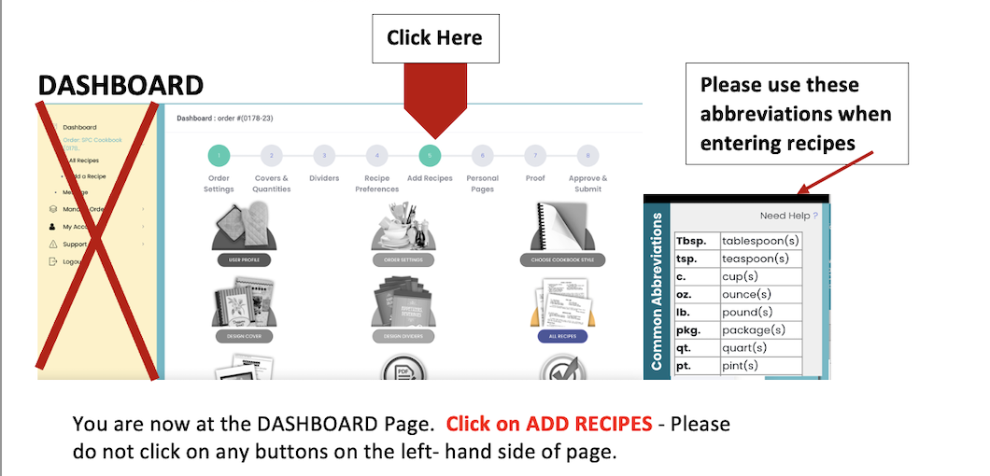

RECIPE FORM
 | EXAMPLE
Status should be DATA ENTRY | Please do not select any other options.
Category: Select Category | 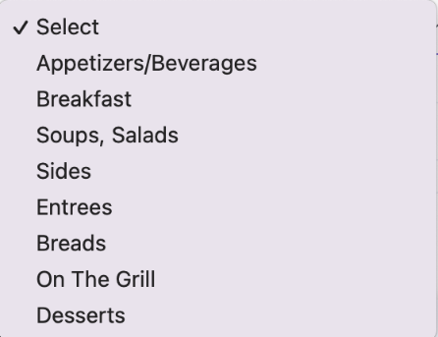
*If Category has a Subcategory, an additional selection list will display, select applicable subcategory. | 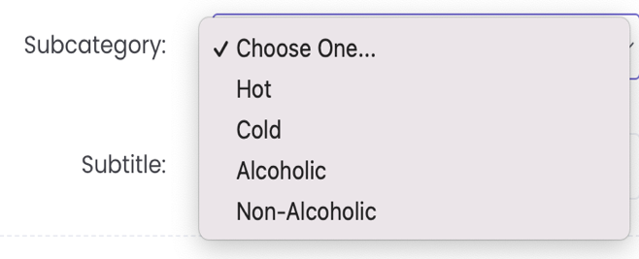
Title: Name of Recipe
Subtitle: If applicable, input recipe source | From the book – Drinking with the Saints
Recipe Contributors: Enter First Name/Last Name | Jane Doe
Contributor Information: how are you connected with SPC? | Parishioner  Daughter-in-law of Parishioner  Owner of Stacy’s Diner  Friend of Parishioner
Additional Contributor Information: N/A
Recipe Part Type: Select ingredients List
Add a title to the ingredient list:  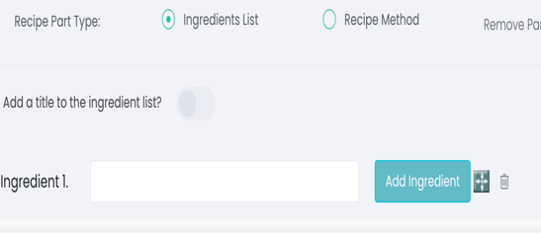 | - If your recipe is a one step process, ie a recipe for a sauce there is no need to add a title. Just start adding ingredients.  - If your recipe has several parts, ie lasagna that involves a recipe for the sauce and for preparing the lasagna, activate that option and type the title, ie For the Sauce and then start adding the ingredients.
Recipe Part Type: Select Recipe Method and type in the steps to your recipe.
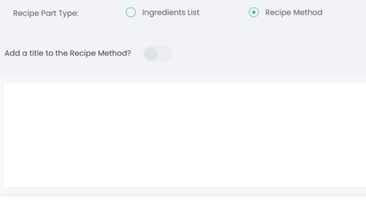

*Please note when adding your method for the recipe, type in paragraph form (no hard returns, numerical lists, etc.) If you need more than one paragraph, select Add Recipe Part to do so.

If your recipe has two parts and separate ingredients, you will need to repeat above process for the second part, click on add title (For Lasagna), Ingredients List, Recipe Method. | 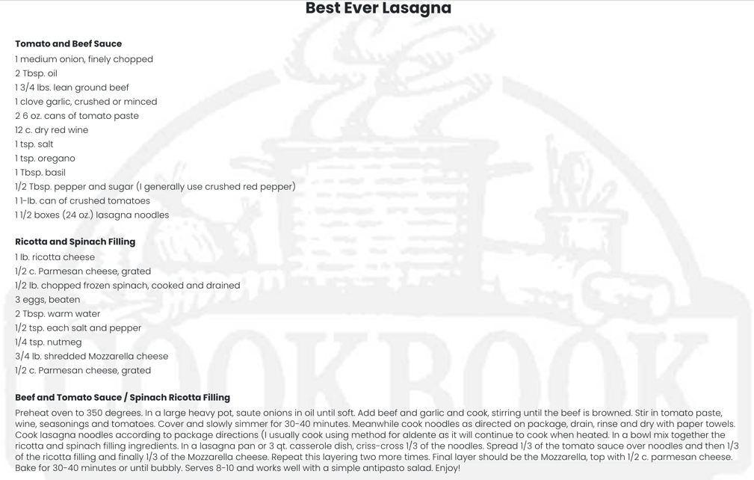
Add Note: This is an optional choice. It is limited to 350 characters. | - My great grandmother’s recipe  - Goes well with……  - If it is from a local restaurant, maybe give them a thank you for sharing  - If it is from a book, i.e. Drinking with the Saints, why that drink is associated with the saint.  Just remember this NOTE is limited to 350
CONGRATULATIONS YOU ARE DONE!!!!

SIMPLY CLICK SAVE OR SAVE AND ADD ANOTHER!

PLEASE NOTE: When saving the recipe you will receive the below
pop -up message, click ok. The recipe will then go into edit mode.

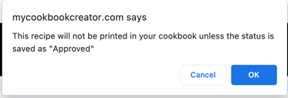

Thank you so much for your contribution to this Parish Initiative!!!!

