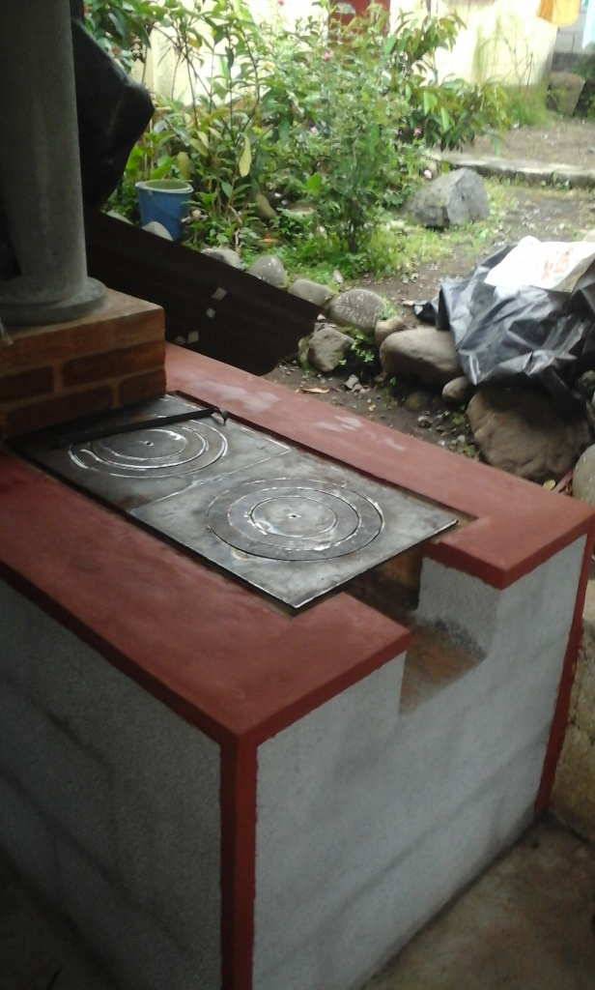

**St. John Neumann**

**Stove Project**

**2021**

Stoves Bring Hope To Families in Guatemala

Fuel-efficient, wood burning stoves are a tremendous blessing for families as they provide a safe environment and cleaner living conditions. Your generosity and support will change the lives of the family receiving a new stove and also benefit the entire community. Pope Francis has often stated that in the Beatitudes we are shown a portrait of the Master and we are called to reflect Him in our daily lives. Thank you for being a “portrait of Jesus” in the lives of so many families in Guatemala! Pope Francis also challenged ‘recognizing ourselves in Christ, enveloped by mercy and the compassion of God is what fills our heart with joy, and it is this that makes our life a beautiful and credible testimony of the love of God for all the brothers we meet every day.” The stove project and the response from this parish has been a shining example of the beatitudes coming alive and clearly an expression of love! Thank you for letting Christ’s love shine through all of you! Many families in San Lucas have been blessed by your generous response. And now more than ever they need to feel your loving thoughts. Thank you for your support of this very important project!

